Kaeser at bauma
40 years of Mobilair – 40 years of quality
Compressed air systems specialist Kaeser Kompressoren has now been developing efficient, economical and dependable portable compressors for 40 years. The company will be celebrating this achievement at bauma 2022 with a multitude of highlights from their extensive range of portable compressed air systems.
When an anniversary year coincides with a year in which the bauma trade fair is being held, then something special needs to be on display at this renowned event in Munich. Coburg-based compressed air specialists Kaeser Kompressoren will be showcasing a cross section of their entire Mobilair product portfolio, with capacities from 1 m³ to 46 m³/min. On display will be machines powered by diesel/petrol engines or electric motors, from the hand-pulled M13 portable compressor to the oil-free compression compressed air colossus that is the M500-2.
The company’s innovative strength will be highlighted by such offerings as the new M13, M17 and M20 series machines, in addition to a completely new operating concept. The most compact portable compressors in the Mobilair range are incredibly versatile and easy to manoeuvre wherever they are needed. The new operating concept is so simple that construction sites applications become mere child’s play.
When it comes to emissions regulations, Kaeser offers a solution for every situation; from the whisper-quiet, emissions-free E-power series to diesel and petrol engines certified to EU Stage V / Tier 4, not to mention models such as the M120 which can operate using high-sulphur diesel.
As is traditional, the company’s generously sized show stand can be found in the outdoor area at its usual location, FM.708/15+17. Patrons are guided by the distinctive tower with its array of Mobilair models standing out in their colourful PE enclosures.

Approved for publication, copy appreciated

Images:

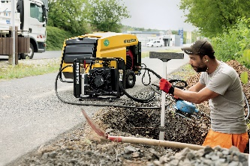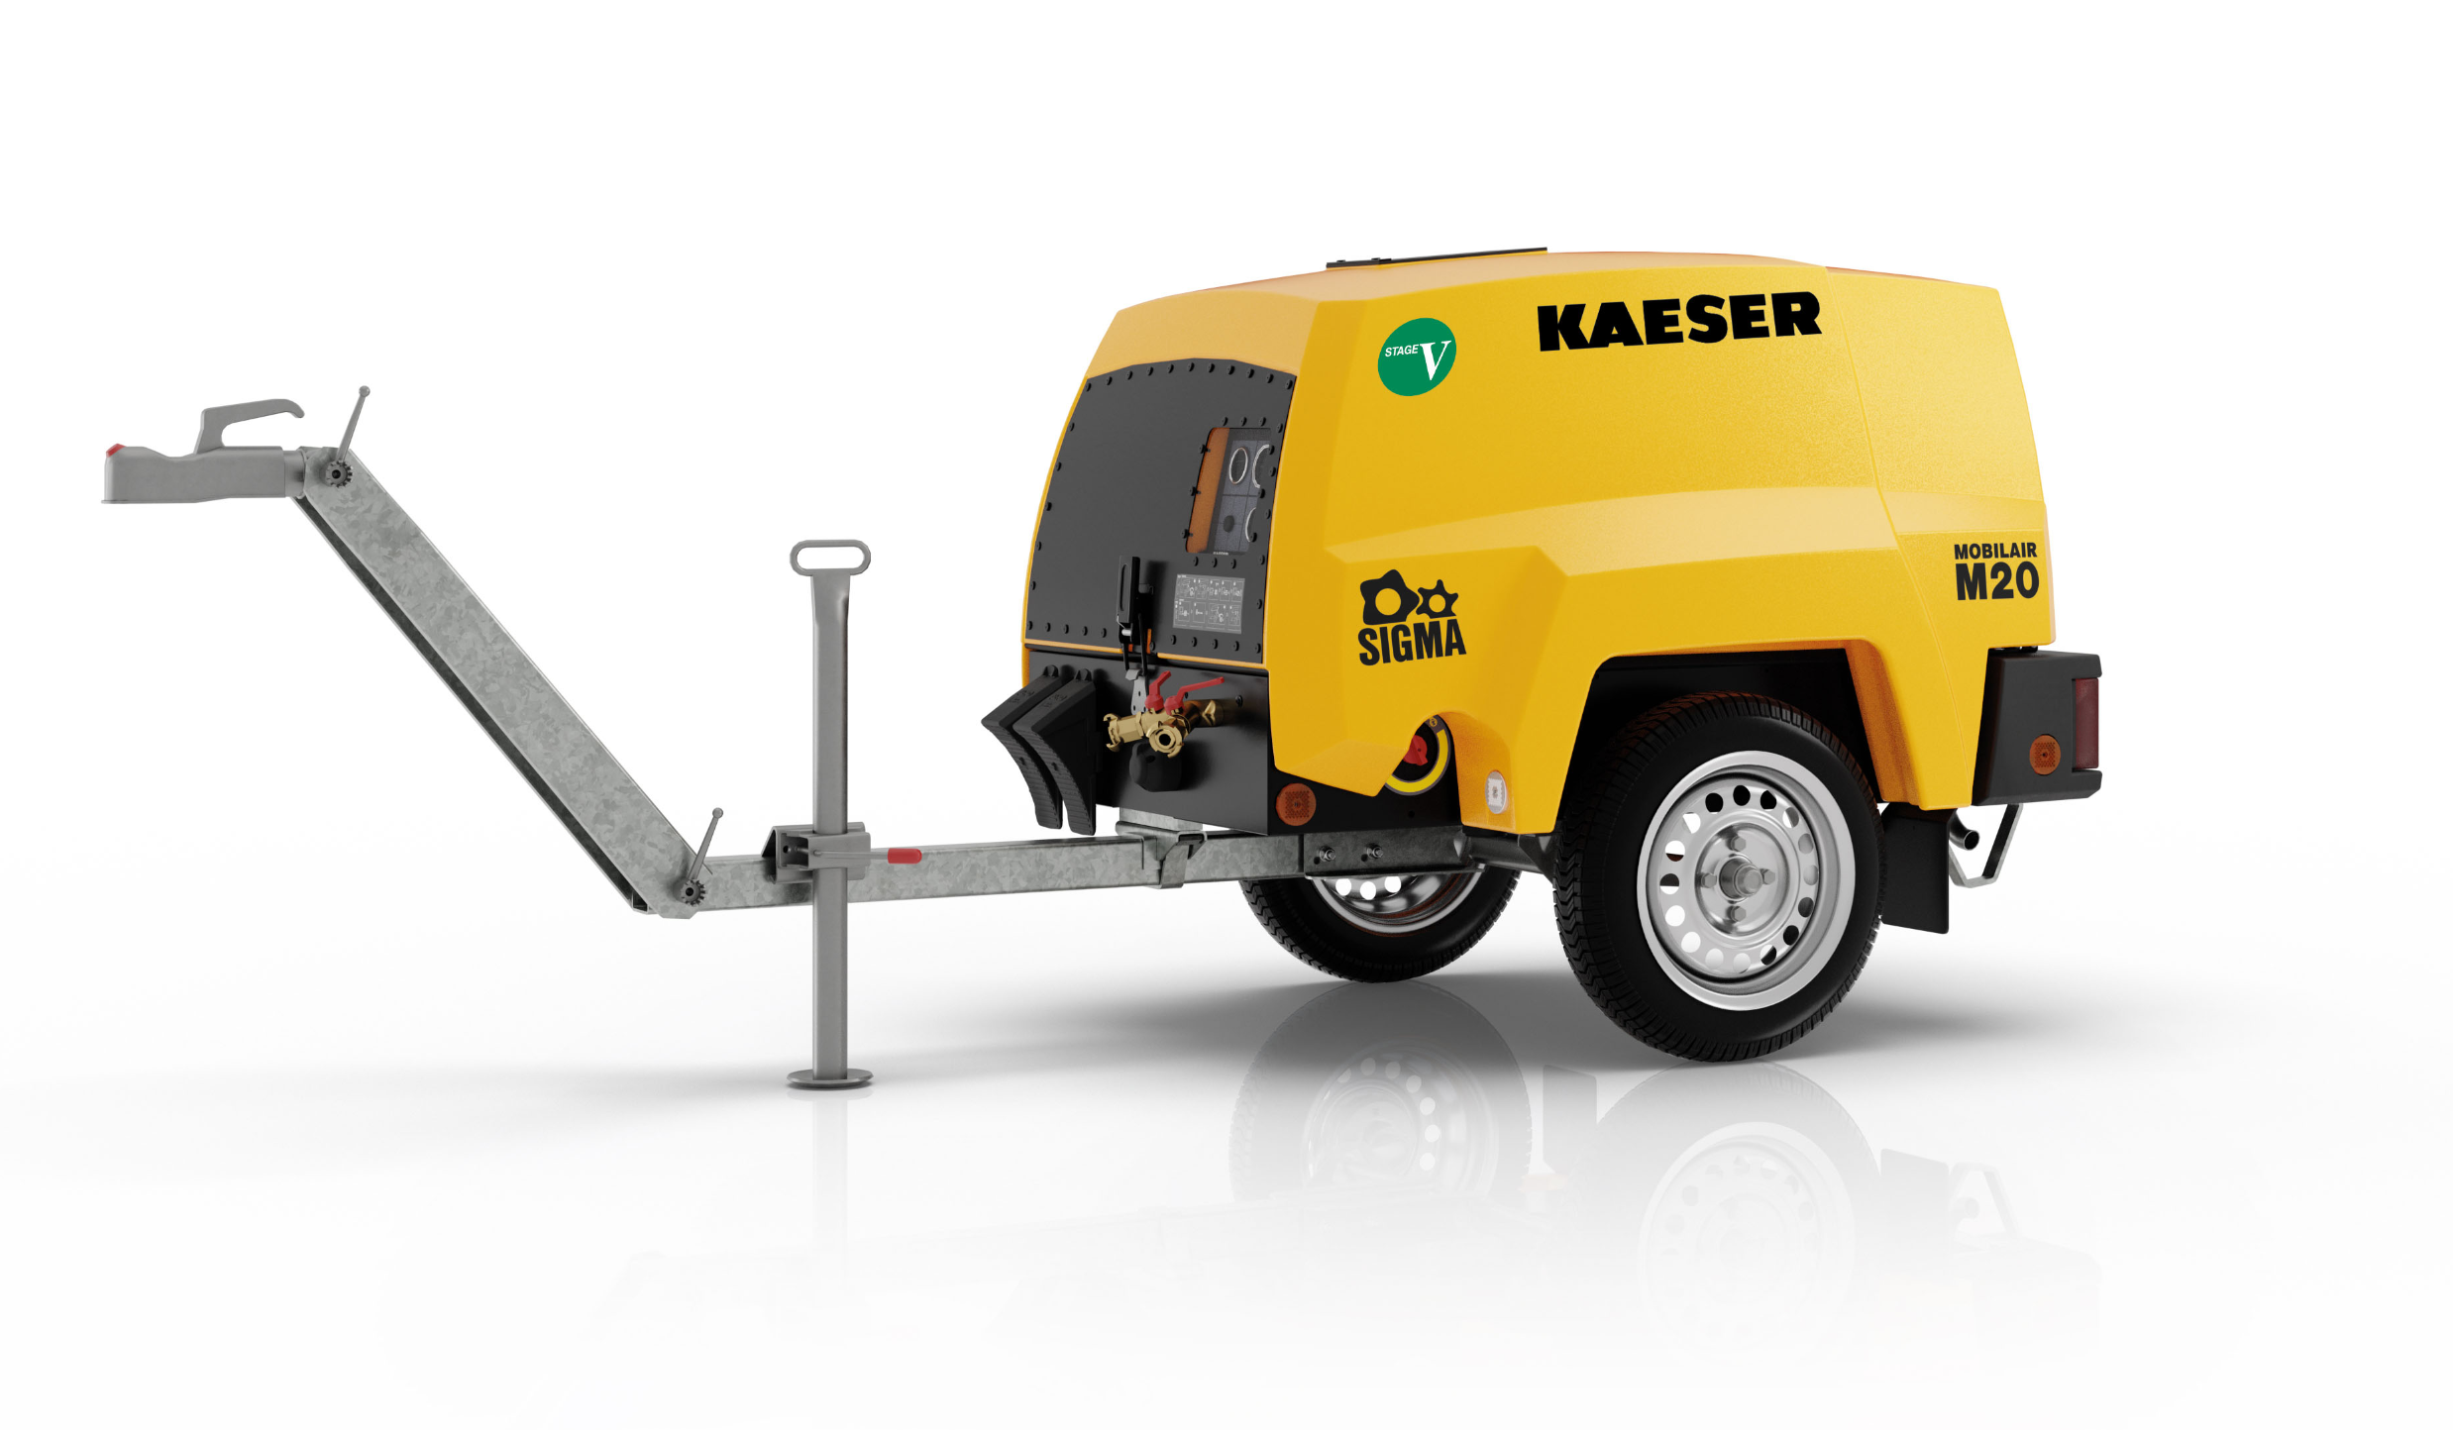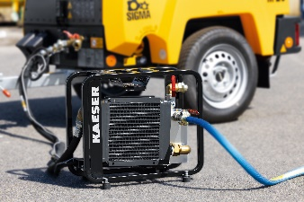

The M13, M17 and M20 can be used for a multitude of applications and are capable of delivering cool, condensate-free compressed air thanks to the optional aftercooler.

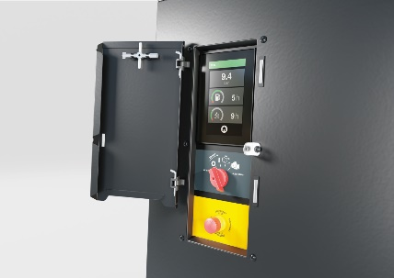

On – Off – Done. Thanks to a new operating concept featuring a rotary switch, operation of Mobilair portable compressors is easier and safer than ever.

