Electric portable compressors
The ideal alternative
Zero emissions and substantial savings in operating costs – wherever a power supply is available, electric portable compressors are a worthwhile alternative to conventional models.
From large building projects to city-centre sites or indoor operations – emission-free electric-powered portable compressors are exceptionally quiet and are significantly easier on the wallet than diesel units. Kaeser is now adding electric versions, powered by motors rated at 15–25 kW, to its highly successful family of Mobilair M27, M31 and M50 compressors. Flow rates range between 2 and 5 m³/min for pressures from 7 to 14 bar.

These machines will be waved through the gates into any environmentally sensitive area, including clean air zones or building sites near hospitals, for example. On large construction projects, where power hook-ups are usually available, the electric compressors make even more sense, as electricity is generally much cheaper than diesel fuel. Another advantage: electric compressors cost far less to maintain. The new models will also come in very handy in tunnel construction or as bridge compressors for industrial stations.

Keeping power consumption to a minimum are the IE3 premium efficiency motors, which meet the IP55 enclosure and Class F insulation standards.

The electric portable compressors are equipped as standard with the advanced Sigma Control Smart controller and Kaeser's Anti-Frost Control. The Sigma Control Smart makes set-up and operation – such as pressure adjustments – quick and simple with an easy-to-read colour display. An automatic start-stop function can also be configured if required. The Anti-Frost Control protects tools from frost and corrosion. A compressed air aftercooler can also be selected to meet higher compressed air quality requirements and the separated condensate is collected in a canister to safeguard the environment.

The models are available with a choice of a rotational moulded polyethylene or metal enclosure and in both road-going and stationary versions.

2.072 keystrokes: − Free for publication, copy appreciated

Pictures:
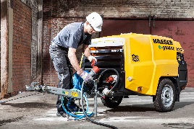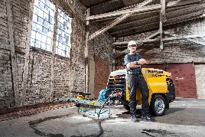
Time-tested Kaeser quality – now available in electric-powered models. The portable compressors can be used under the most stringent operating restrictions.

