High performance filters from Kaeser Kompressoren
Pure compressed air
Corresponding air treatment and filtration is essential for businesses requiring a dependable source of high quality compressed air. Kaeser’s filters not only deliver the necessary performance, but also provide unprecedented energy efficiency.
Kaeser Kompressoren’s filters ensure outstanding efficiency and minimal pressure differential. Low pressure differential means lower energy consumption, but that in itself is not much use if the filter cannot provide the required compressed air quality. Kaeser filters deliver both: Their performance characteristics were determined in accordance with ISO 12500-1, the quality standard for filters, and were tested and verified by an independent body. Accordingly, the new deep-pleat KE (Kaeser Extra) aerosol filter achieves a residual aerosol content of 0.01 mg/m³ with a saturation differential pressure of no more than 200 mbar.
The filter range covers four different element grades for filtration of aerosols, dust and oil vapours. Compressed air can therefore be treated to suit the needs of the specific application in accordance with ISO 8573-1 purity classes. These innovative filters are suitable for pressures up to 16 bar at temperatures of up to 66° C and will be initially available in nine enclosure sizes for flow volumes up to 32.0 m³/min.
Tailored compressed air purity with maximum efficiency
The patented in-house development of the element head is the result of Kaeser’s decades of compressed air engineering expertise. It gently redirects the air flow so that it is evenly distributed across the innovative filter media. In addition, especially large filter surfaces ensure optimum filtering rates, which results in high filter efficiency with minimal pressure loss.
Faultless element replacement
A bayonet fitting is used to connect the filter head and housing. An innovative integrated positive positioning guide ensures that the housing and element are always automatically correctly joined following filter element and seal replacement. A stop screw fixes the housing in its final position and seals it at the same time. If improperly assembled, the connection does not close and compressed air can be heard escaping.
Durable, easy-to-install housing
The Kaeser filter housings are made of corrosion resistant aluminium. They are available in various nominal sizes to make installation as easy as possible. Numerous options and a comprehensive selection of accessories are also available.
Kaeser's finely graded filter range ensures reliable and efficient compliance with all ISO 8573-1 quality classes. The filter models are precisely matched to the compressors and air treatment components and can be combined to suit the specific needs of the application.
Dependable purity for high flow rates
Kaeser Kompressoren also makes the same element technology available in its tank filters. Their exceptionally low differential pressure provides the potential for significant energy savings for flow rates up to 336 m³/min. High quality corrosion-resistant tanks, in combination with the coalescence filter and the electronic level-controlled ECO-DRAIN 31 F condensate drain equipped as standard, play a key role in achieving impressive filtration efficiency.
Approved for publication, copy appreciated

Caption:
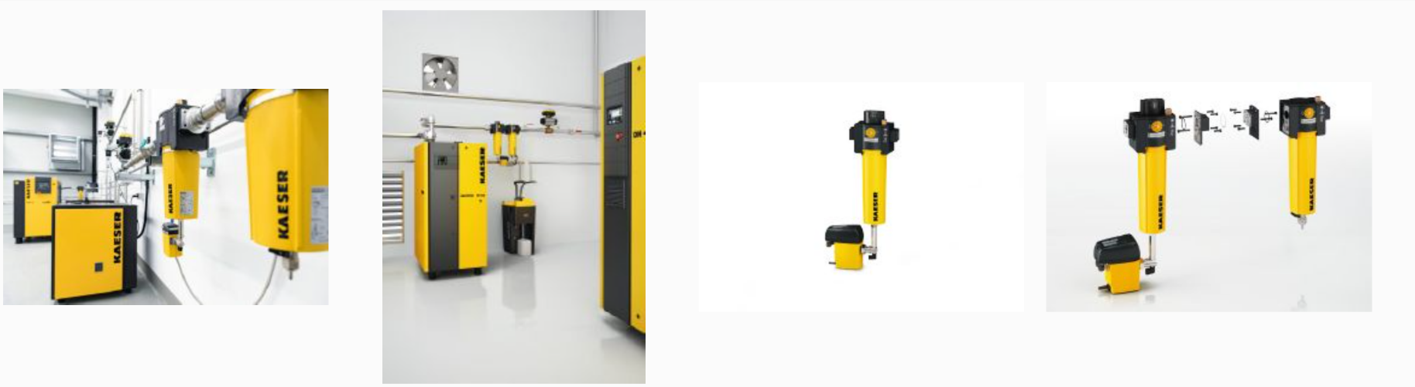
Kaeser’s filters provide exceptional efficiency with minimal pressure loss.

