CSG series rotary screw compressors
Purity and efficiency at the forefront
Pharmaceuticals, foodstuff, healthcare, chemicals – these industrial sectors place especially high demands when it comes to compressed air quality. For those who wish to achieve these requirements cost-effectively, CSG rotary screw compressors from Kaeser represent the perfect choice. These new models are particularly efficient and require very little installation space.
The CSG series provides highly efficient compressed air generation, yet requires 19 percent less floor space than its predecessor range. Models are available with air- or water-cooling, with integrated refrigeration dryer or i.HOC (Heat of Compression dryer), and for flow rates ranging from 4 to 15 m³/min. For applications with fluctuating compressed air demand, speed-controlled “SFC” versions are available.
The CSG series is equipped with high-quality, durable airends featuring the energy-efficient Sigma Profile for which Kaeser is world-renowned. The rotors now feature an innovative new wear-free PEEK coating, which is also particularly temperature-resistant. Biocompatible, FDA-certified and in compliance with European requirements for food contact materials, this coating is perfectly adapted for the pharmaceuticals and foodstuff industries.
When it comes to energy efficiency, the CSG series is the star of its class. Kaeser was uncompromising in its pursuit of efficiency when developing the drive, cooling and compression systems for these models. Therefore, the range is equipped with IE5 Ultra Premium Efficiency synchronous reluctance motors and water jacket cooling on both compression stages – on both air- and water-cooled systems. The fibre-free pulse dampers fitted to the CSG operate on a broad spectrum and at very little pressure loss.
These and other optimisation measures have enabled system efficiency to be improved further. This means that the CSG series delivers 16 percent higher flow rate for the same rated motor power, whilst maximum working pressure has been increased from 10 to 11 bar.
A further aim of product development was to make the compressor heat easily available for use by customers, thus allowing maximum reduction of their CO_{²} footprint.
To this end, Kaeser offers an integrated i.HOC desiccant dryer on both air- and water-cooled systems. It cleverly uses compressor exhaust heat to regenerate the desiccant with minimal energy consumption, thereby providing reliable and stable, oil-free compressed air with pressure dew points down to -30 degrees C, even under harsh ambient conditions.
For water-cooled models, Kaeser offers innovative, integrated heat recovery options which can easily be adapted to customer requirements.
The integrated Sigma Control 2 compressor controller not only provides dependable and energy-efficient control of compressor operation, but also enables connection to master compressed air management systems. Furthermore, it provides bearing and winding temperature monitoring for the drive motor as standard, as well as vibration monitoring for the compressor.
All Kaeser rotary screw compressors impress when it comes to the question of sustainability. Not only do they operate extremely economically, but they are produced in Germany to the highest quality standards and requirements. Exceptional durability means they can serve a company for many decades to come. Should it ever become necessary to replace them, many of the materials used in their manufacture are recyclable. When it comes to your compressed air supply, Kaeser also represents a plus point with regard to nature and the environment.
Free for publication, copy appreciated

Images:

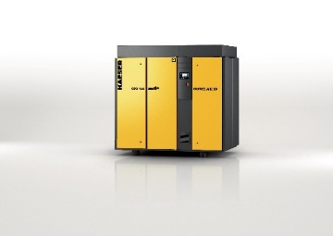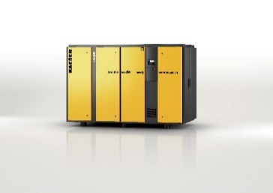

The CSG series (on the right with integrated i.HOC rotation dryer) delivers compressed air dependably and efficiently for oil-free applications.

