

Growth for compressors

Futuristic manufacturing
Last Monday, Kaeser Kompressoren launched a project to build two new innovative compressor factories which, when finished, will cover a floor area of over 20,000 square metres.
Coburg – The Coburg-based compressed air specialist Kaeser Kompressoren has been reporting healthy, steady growth for years: No wonder there is a need for increased manufacturing capacity.

The newly planned intelligent factories will boast sustainable higher productivity and flexibility and will primarily serve to build state-of-the-art rotary screw compressors, which represent one of the company's core competencies.

"The investment will position us ideally for further growth as we move forward. With Industry 4.0 at the forefront of our strategy, compressor manufacturing will be networked with internal and external logistics and their sales and marketing arms at this factory of the future. The aim is to build top-quality new and innovative products, optimise productivity and minimise lead times. Needless to say, we wish to remain true to our Coburg location and will therefore build these innovative facilities at our traditional site" said company CEO Thomas Kaeser.

The manufacturing halls will be built parallel to Staatsstraße and will extend all the way from the old to the new roundabout. A logistics facility will join the two structures at the midpoint. A bridge at the back will automatically transport the finished compressors to the ultramodern distribution centre.

The building is scheduled to be completed in June 2016. Compressors are used at all types of plants in all industry sectors, including mechanical OEMs, automotive, pharmaceuticals, chemicals, wood processing and furniture making, mining and construction, as well as for fish farming, at wastewater treatment facilities and for conveying loose goods. Compressed air is even used in hospitals and by dentists.

File: pm-spatenstichhallen-üreg-de/26. Mai 2014
2058 keystrokes − Free for publication, copy appreciated
Images:
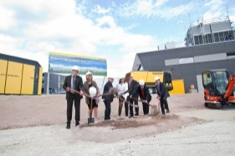
Ground-breaking ceremony for two new innovative Kaeser Kompressoren factories (from left to right): Bernhard Brand (Rotary Screw Production Centre), Dr. Birgit Weber (second Mayor of Coburg), Thomas Kaeser, Tina-Maria Vlantoussi-Kaeser, Lord Mayor Norbert Tessmer, Dirk Eichhorn-Mödel (Kaeser construction company), Friedrich Herdan (President of Coburg's Chamber of Commerce and Industry).
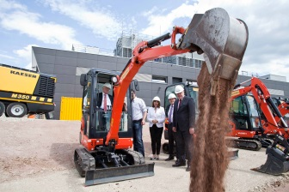
A mini excavator was used following the traditional ground-breaking ceremony: Thomas Kaeser, Alf Luthardt (construction company), Tina-Maria Vlantoussi-Kaeser, IHK president Friedrich Herdan and Lord Mayor Norbert Tessmer

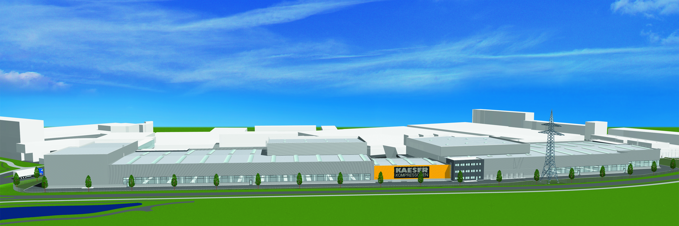

The two new manufacturing halls will extend along the entire long side of Kaeser's main manufacturing site.

About Kaeser Kompressoren

Kaeser Kompressoren is a leading global manufacturer and provider of compressed air systems products and services. The company's portfolio covers all aspects of compressed air generation, treatment and distribution. Reliability, energy efficiency and cost-effectiveness are always top priorities. The range of products includes stationary rotary screw and reciprocating compressors, portable compressors and dental compressors. Also offered are compressed air management systems, vacuum pumps, rotary blowers, filters, dryers, compressed air tools and accessories, as well as consultancy, planning, compressed air demand analysis and contracting. The entire range of products and services was designed with maximum compressed air efficiency in mind.

The family enterprise is based in Coburg and was founded in 1919 by Carl Kaeser Senior. Thomas Kaeser, his grandson, heads up the company today together with his wife Tina-Maria Vlantoussi-Kaeser. Kaeser Kompressoren has factories in Coburg, Gera and Lyon and is represented in over 100 countries by its own subsidiaries and exclusive trading partners. The compressed air specialist employs approximately 4,800 people worldwide, of whom 1,900 are based in Germany.

