

On the safe side with Kaeser compressors
Kaeser Products: EMC Tested and Certified
Compressors can cause interference with other systems and machines, or may be affected as result of interference themselves. To prevent this problem from occurring, all units should comply with European and national legislation regarding electromagnetic compatibility (EMC). All Kaeser products are EMC tested and carry the VDE-EMV (German Association of Electricians - Approval of Electromagnetic Compatibility) quality approval seal.

Machines and systems which can cause interference to, or be affected by, the operation of other machinery or equipment are subject to national and European EMC regulations. Standards regarding areas such as interference sensitivity, bound/ unbound interference emissions and implications for the electrical supply aid compliance with these regulations. Adherence to these legal obligations is checked and monitored by local authorities who have the power to carry out on-site inspections of ‘suspect’ machines at any time and are even able to take away machinery for further examination.

Compressor installations comprise various electrical, electronic and mechanical systems, with installation of frequency converters for speed regulation becoming increasingly popular. As these systems can suffer from or cause interference, they should fulfil EMC standards in order to guarantee perfect operation. However, it is not uncommon to find a compressor installation that has not been subjected to any inspection whatsoever, or which has undergone unsatisfactory examination. Furthermore, systems which have had just one component tested, such as the frequency converter, but which have not had the entire system checked do not comply with regulations.

Kaeser, however, has all of its products tested to regulation standards by experts from the VDE (German Association of Electricians) Test and Inspection Institute in Offenbach, Germany, who also provide comprehensive test documentation.

The VDE also regularly inspects production facilities at Kaeser who, as a result, is able to label its products accordingly. In addition to the CE symbol, applicable Kaeser products bear the VDE-EMV quality approval symbol which confirms that they have been tested in accordance with all relevant EMC regulations and are found to operate perfectly.

File: o-emv-en
2.349 Keystrokes − Free for publication, Copy appreciated

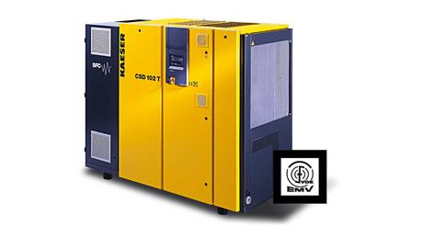
All Kaeser products are tested for electromagnetic compatibility and carry the VDE-EMV quality approval symbol. The symbol confirms compliance with EMC regulations and European EMC guidelines.

