
New refrigeration dryer with innovative thermal storage technology
Huge storage density boost
For a refrigeration dryer of its performance rating, the new Secotec TF from Kaeser Kompressoren is incredibly compact and of course delivers an efficient and dependable supply of quality compressed air. Thanks to its innovative thermal storage system and low energy consumption, the Secotec TF pushes the boundaries of compressed air refrigeration dryer performance further than ever before.
Efficient and reliable compressed air treatment is essential when it comes to economical compressed air production. The second generation of Kaeser’s highly successful energy-saving Secotec refrigeration dryers is truly impressive: Not only do they take up only about half the space of comparable first generation dryers despite having a higher specific rating and lower pressure drop, they are also significantly lighter and uses significantly less energy.
The extremely efficient Secotec series thermal storage dryers are now available for air flows up to 34 m³/min and consequently now cover a delivery range from 17 to 34 m³/min. It's all made possible by an innovative thermal storage system, which contains a phase-change material (PCM) that is 98 percent denser than conventional storage media. Thermal energy is stored as the PCM cycles from a solid to a liquid state. The innovative Secotec TF series is therefore considerably more compact compared to conventional models with the same thermal storage capacity. Their footprint is up to 46 percent smaller and they are approximately 60 percent lighter than other thermal storage dryers. It has therefore never been easier to find space for, and install, Secotec TF dryers, particularly as two sides of these units can be installed next to a wall.
The refrigeration dryer includes a Sigma Control Smart microprocessor-based controller, which controls the thermal storage process. It has an alarm and service message memory, as well as remote on/off control capability.
The dryers’ compact design also made it possible to reduce the pressure loss across the dryer to 0.15 bar. Compare this to conventional dryers, where the pressure drop is 0.20 bar and higher. The low energy requirement of Secotec TF dryers is also remarkable. The meticulously designed new system uses less than 87 Watts per cubic metre of air to be dried per minute, which is a new benchmark in the field of refrigeration dryers; conventional models use on average 200 to 250 Watts. Furthermore, the new design ensures minimal maintenance requirement and service work is made quick and easy. Many practical options are available for the new Secotec TF, including side-mounted compressed air connections.
The new and efficient TF models are available now as air-cooled versions.
File name: d-secotectf340-Eng
2788 keystrokes − Free for publication, copy appreciated

Caption:
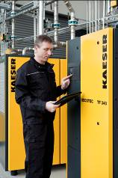
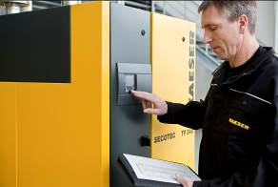
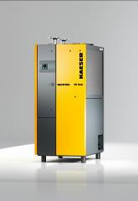

The new Secotec TF dries large volumes of compressed air with impressive energy efficiency. Space-saving refrigeration dryers featuring highly efficient partial load control are now available for the first time thanks to the compact thermal storage medium.

